阮正鑫 120032910012
- The result of f*I is [ 0 1 4 8 11 12 10 8 13 15 6]
- Use the larger $σ$ to detect large scale edges.
High threshold.
- The result of hybrid image is shown as follows,
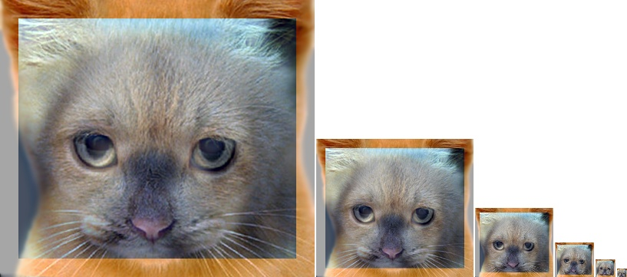
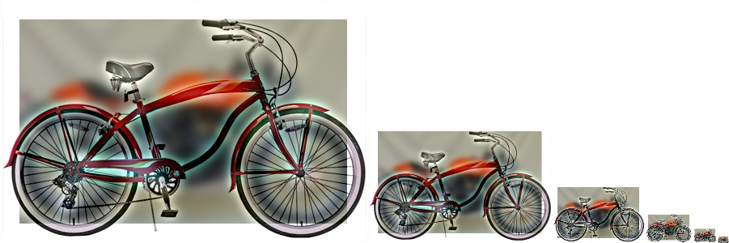
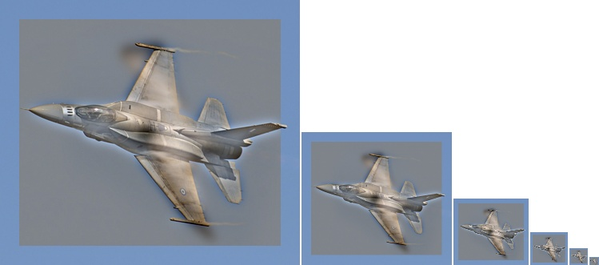

Hybrid images demonstrate how certain frequencies dominate at certain distances. Most notably, high frequencies dominate when the object is close you, while lower frequencies dominate when it is further away.
- (1)The result of Harris corner detector is shown as follows,
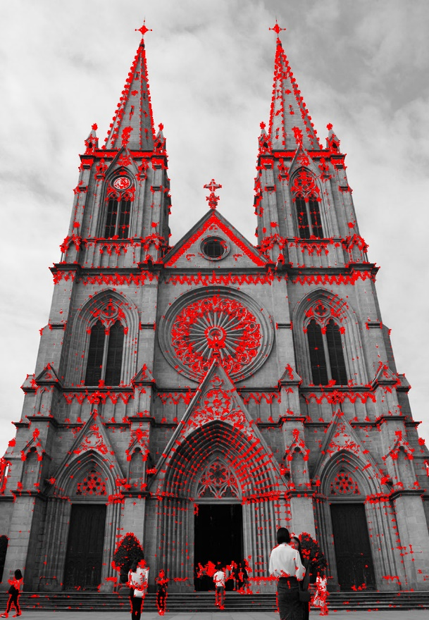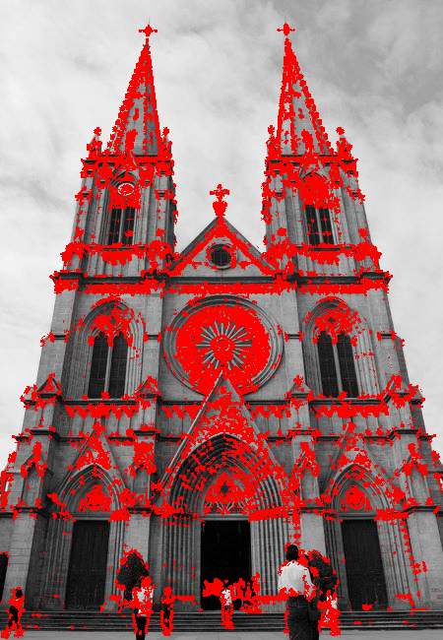
Original result scaled result
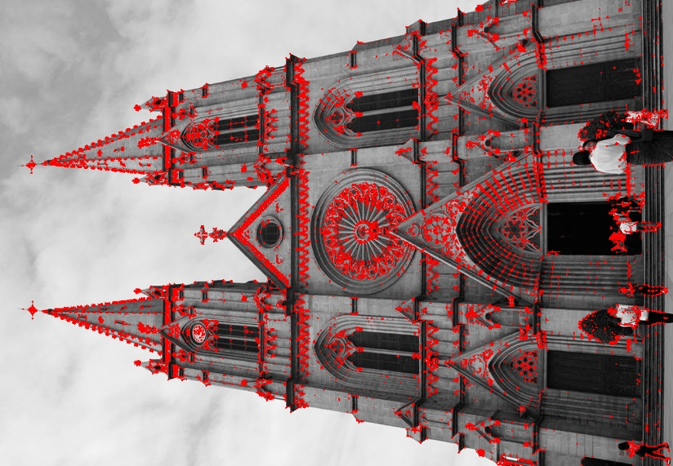
Rotation result
As can be seen from the above picture, rotation and scaling will not change the result of Harris corner detector.
(2)
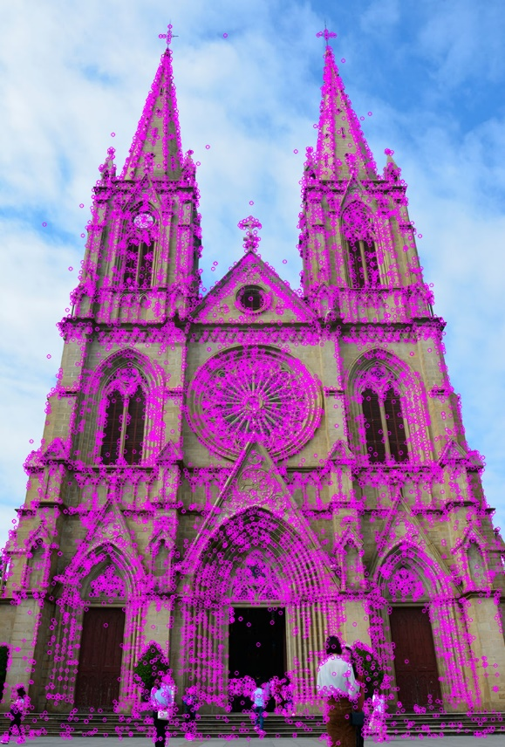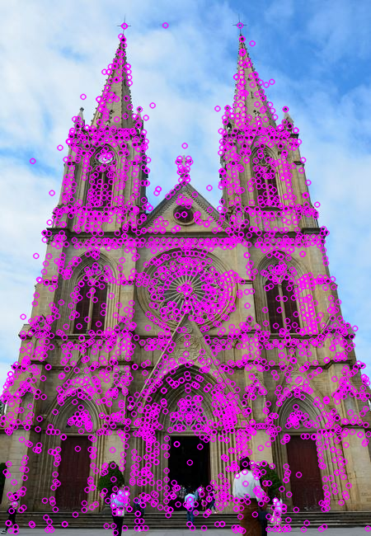
Original result scaled result
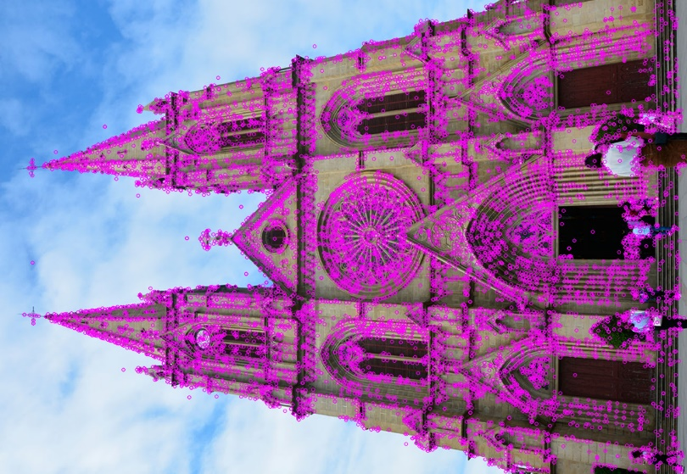
Rotation result

